EXPERIMENT 11: Implementation of Learning Algorithms for an Application

**Name :** D V Ravi Sridhar

**Reg No. :** RA1811003010732

**Section :** CSE – D2

# Date : 26/04/2021

**Problem Description :-**

We will see how the Python Scikit-Learn library for machine learning can be used to implement regression functions. We will perform linear regression.

In this regression task we will predict the percentage of marks that a student is expected to score based upon the number of hours they studied. This is a simple linear regression task as it involves just two variables .

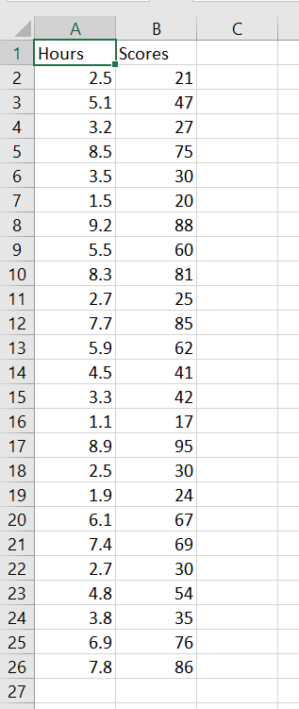**Dataset for the application :-**

**Code :-**

import pandas as pd import numpy as np

import matplotlib.pyplot as plt

%matplotlib inline

dataset = pd.read_csv('D:\Datasets\student_scores.csv') dataset.shape

(25, 2)

dataset.head() dataset.describe()

dataset.plot(x='Hours', y='Scores', style='o')

plt.title('Hours vs Percentage') plt.xlabel('Hours Studied') plt.ylabel('Percentage Score') plt.show()

X = dataset.iloc[:, :-1].values y = dataset.iloc[:, 1].values

from sklearn.model_selection import train_test_split

X_train, X_test, y_train, y_test = train_test_split(X, y, test_size=0.2, random_state

=0)

from sklearn.linear_model import LinearRegression regressor = LinearRegression() regressor.fit(X_train, y_train) print(regressor.intercept_) print(regressor.coef_)

**Screenshot from Output :-**

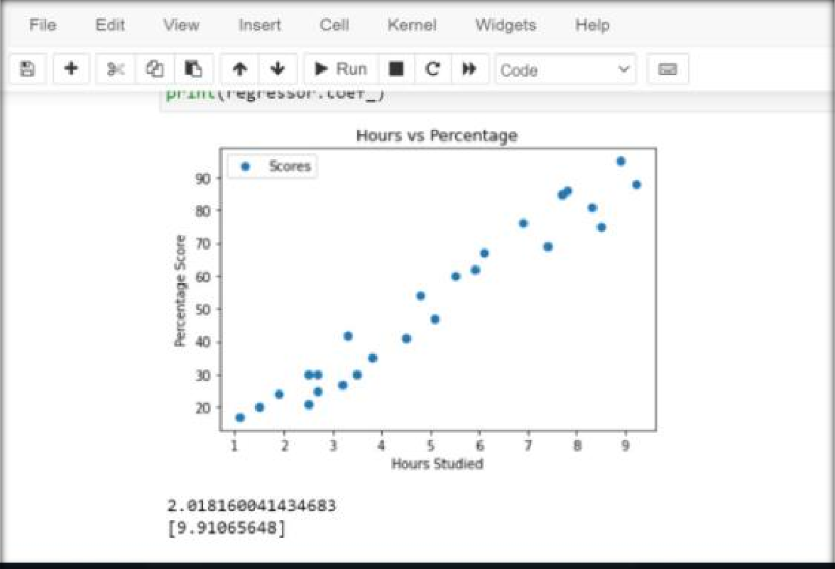

**Result**

The experiment was successfully implemented and executed.